Institute of Computer Technology

B. Tech Computer Science and Engineering

Subject: Basics Of Communication Systems (2CSE202)

**PRACTICAL-7**

**AIM:** To create Wireless Local Area Network

First, select all devices routers and switch

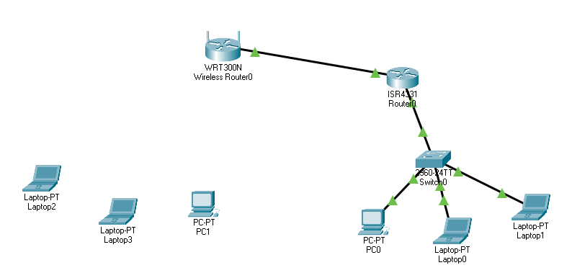

Then let’s configure router 0 wired one

On ethernet0/0/0, we have connected switch network whose ip address is 192.168.1.1/24

On 0/0/1, we have connected wireless one whose ip address is 192.168.2.1/24

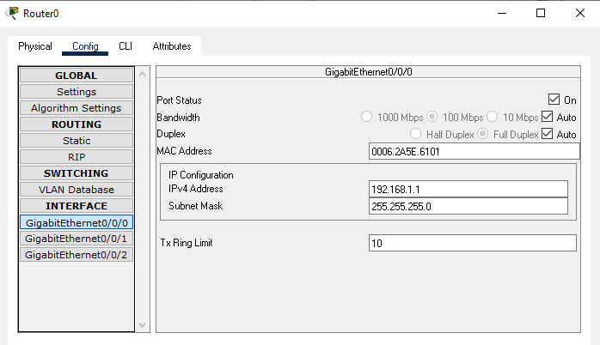

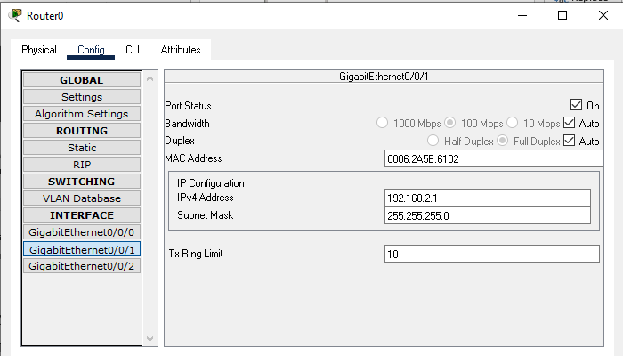

Now let’s give ip address to pcs connected to wired router through switch Laptop 0 ip address

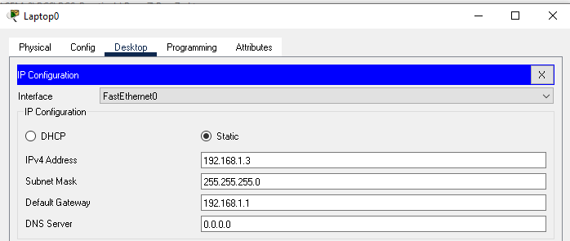

Laptop 1

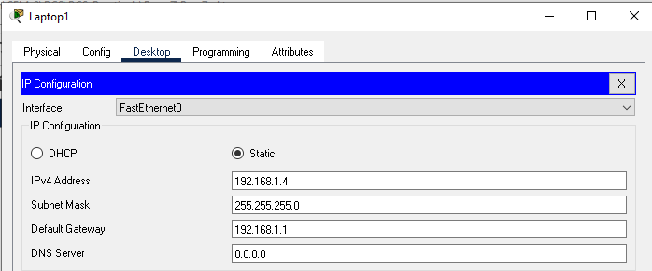

Pc0

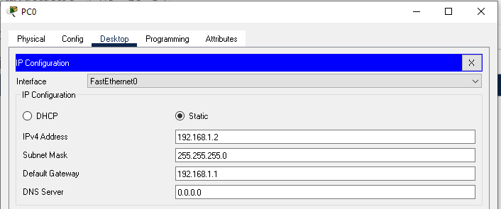

Hence, all wired network side is cleared and we have given ip address to it Then now configuration of wireless router.

Then in wireless router open internet static like below

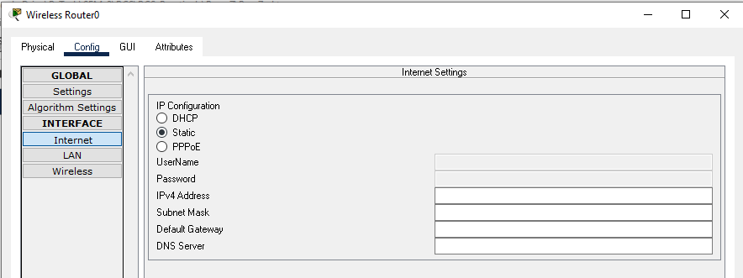

Configure that

Then give default gateway as 192.168.2.1 which is 0/0/1 interface ip of wired router which is connected to wireless router

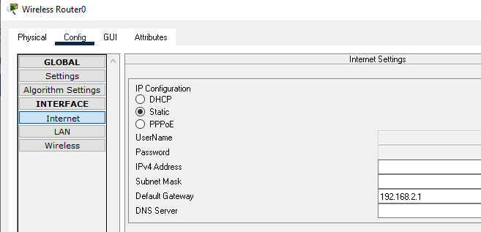

Then select next option lan and give ip address as below

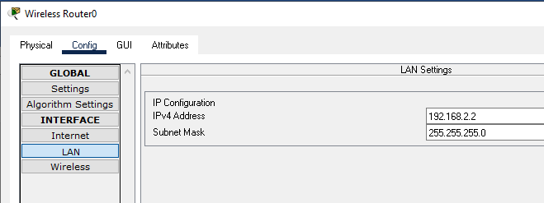

Then give security key network name to router wireless its not mandatory but always secure to use

So I will use it

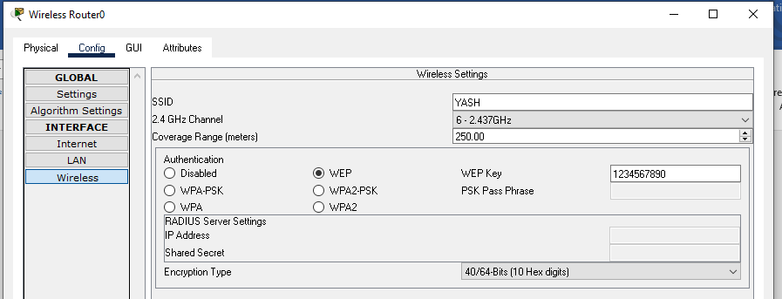

AS I have given name and WEP key and password

Now for devices connected in wireless router network should need to add wireless port so remove one port and add another port

Follow below mentioned method for all pcs and laptop see the one configuration of laptop

Click on laptop turn it off

Then add port WPC300n

REMOVE one module and add that module

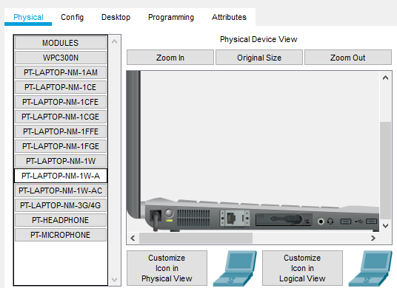

Then turn it on

Go to desktop wireless

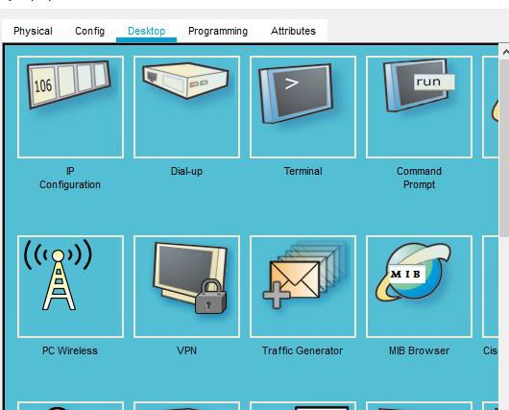

Then select PC Wireless. Then in dialog box click on CONNECT.

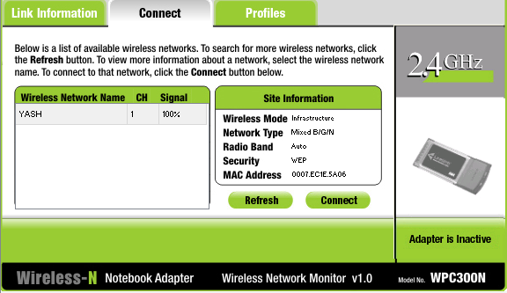

See it also shows that link has been connected and securely connected

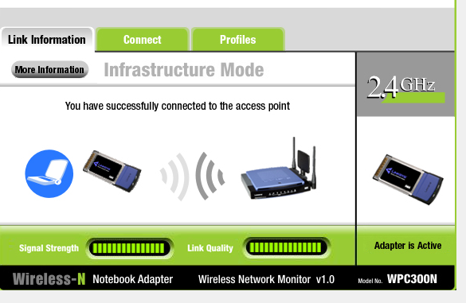

Now, check the connections.

